

**Department of Computer Engineering**

**Faculty of Technology, Dharmsinh Desai University**

**College Road, Nadiad-387001**

**B.Tech. CE Semester – VI**

**Subject:** Object Oriented Software Engineering

**Project Title:** Online Cab Booking System

**Developed By**

Darji Dipesh – CE022, 17CEUBS137

Darshan Gohel – CE037, 17CEUBG002

**Guided By**

Prof. Jatayu H. Baxi

Department of Computer Engineering

Faculty of Technology,

Dharmsinh Desai University



**DHARMSINH DESAI UNIVERSITY**

CERTIFICATE

This is to certify that the project entitled “**Online Cab Booking**” is a bonafide report of the work carried out by

1) Mr. DARJI DIPESH, Roll No: CE022, Student ID No: 17CEUBS137

2) Mr. DARSHAN GOHEL, Roll No: CE037, Student ID No: 17CEUBG002

of Department of Computer Engineering, semester VI, under the guidance and supervision for the subject Object Oriented Software Engineering. They were involved in Project training during academic year 2020-2021.

Prof. Jatayu H. Baxi Dr. C.K. Bhensdadia

Department of Computer Engineering, Head, Department of Computer Engineering,

Faculty of Technology, Faculty of Technology,

Dharmsinh Desai University, Nadiad Dharmsinh Desai University, Nadiad

Date:

**Contents**

1. Front Page...........................................................................1
2. Cretificate............................................................................2
3. Abstract...............................................................................4
4. Introduction........................................................................5
5. Software Requirement Specification..................................6
6. Design................................................................................10
7. Use Case Diagram.......................................10
8. Class Diagram..............................................11
9. Sequence Diagram.......................................12
10. Activity Diagram..........................................13
11. State Diagram…………………………………………….14
12. E-R Diagram……………………………………………….15
13. Data Dictionary………………………………………….16

**5**. Implementation Detail......................................................19

**6.** Screen-shots.....................................................................21

**7.** Conclusion........................................................................26

**8.** Limitation and Future Extension......................................27

**9.** Bibliography......................................................................28

**Abstract**

This project mainly deals with creating an application regarding cab booking and checking availability of vehicles. Cab booking system provides reliable online cab(cars) booking facility to people in the various cities in India, free of cost. Cab acts like a bridge between the cab operators and customers/users who book a cab. This brings together the registered travel cab operators and the customers. Free service to the travelers/users who want to go for booking a cab.

**Introduction**

Here the customers can book a cab/taxi/car by viewing all the cab details and pricing details available, according to the selected city and area. It is reliable service provided to both customers and operators. This provides service with well conditioned new vehicles, with experienced drivers for a happy journey of customers.

* Technology Used
* ASP.NET
* MySQL
* Platform
* Desktop
* Tools
* Visual Studio 2015

**Software Requirement Specification**

**Online Cab Booking**

* **Types of Users:**

1.Admin

2.End User

3.Driver

**R.1: Admin**

**R.1.1: View Daily Earning**

**Input**: User selection

**Output**: Details of daily cabs fair.

**Description**: Admin can view fairs earning and he can see daily profit and loss.

**R.1.2: Provide Offers**

**Input**: Information about offers

**Output**: Success message

**Description**: Depending upon the daily use of the cabs by customers admin can provide different offers and concession.

**R.1.3: Manage drivers**

**R.1.3.1: Remove driver**

**Input**: User selection

**Output**: Success message

**Description**: Admin can remove any driver from company

**R.1.3.2: View driver Information**

**Input**: User selection

**Output**: Displayed driver information

**Description**: Admin can search/sort driver information with respect to different information like number of fairs per day, ratings, car type, etc.

**R.1.3.3: Accept Request**

**Input**: User selection

**Output**: Message sent to driver

**Description**: Admin can Accept the request of driver for

make the cab driver of system and respective message sent to

the driver.

**R.2: Driver**

**R.2.1: Login**

**Input**: Required credentials

**Output**: Driver Interface.

**Description**: Driver can log into the system.

**R.2.2: Signup**

**Input**: Required Information

**Output**: Success Message

**Description**: Driver can sign up into the system by providing Required information like car type, car fuel type, timing of his job, address information, etc.

**R.2.3: Accept Request**

**Input**: User selection

**Output**: Success message send to the customer.

**Description**: Driver can accept request given by customers and successfully message sent to the particular customer.

**R.2.4: Reject Request**

**Input**: User selection

**Output**: Reject message send to the customer.

**Description**: Driver can reject request given by customers and successfully message sent to the particular customer.

**R.2.5: View daily earnings**

**Input**: User selection

**Output**: Daily earning will be displayed

**Description**: Driver can see his daily services which has been provided by him to customers and can see daily earning of his.

**R.2: Customer**

**R.3.1: Login**

**Input**: Required credentials

**Output**: Customers Interface.

**Description**: Customers can log into the system.

**R.3.2: Signup**

**Input**: Required Information.

**Output**: Success Message

**Description**: Customers can sign up into the system by providing Required information like health information, Contact information, address information, etc.

**R.3.3: View cabs**

**Input**: Required information

**Output**: Details of corresponding cabs

**Description**: Customer have to provide fair details like source, destination, time, car type, car fuel type, AC/non-AC, etc.

**R.3.4: Book cabs**

**Input**: User selection

**Output**: Request is sent to particular driver

**Description**: Customer can book any cabs for his fair by selecting preferable cab.

**R.3.5: Cancel cabs**

**Input**: User selection

**Output**: Request is sent to particular driver

**Description**: Customer can cancel any cabs for his fair by selecting already booked cab.

**R.3.6: Payment**

**Input**: Information regarding payment

**Output**: Success message to customer and driver

**Description**: Customer can pay amount of service of fair by selecting type of the payment and customer as well as driver receives the successful message for payment.

**Design**

1. Use Case Diagram



2.) Class Diagram



3.) Sequence Diagram

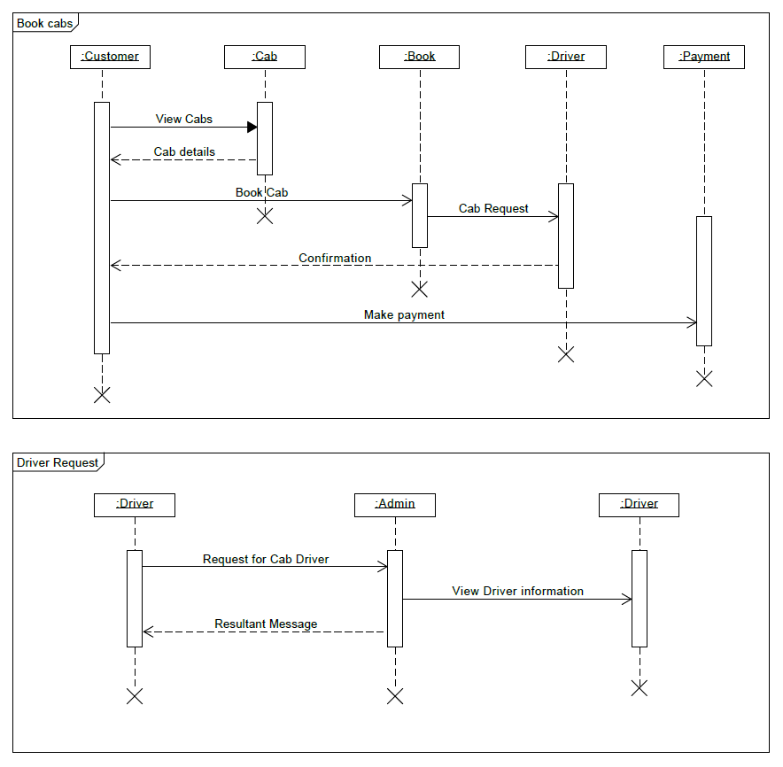

4.) Activity Diagram

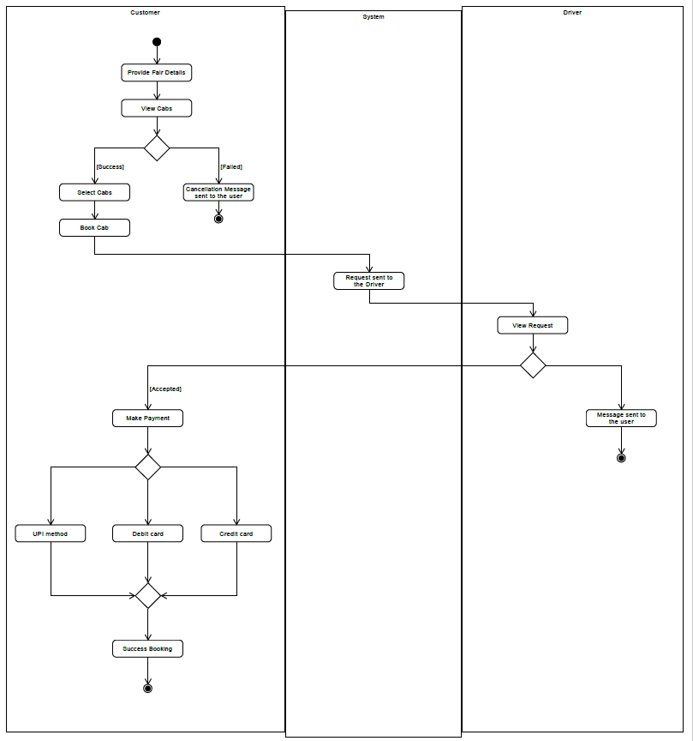

5.) State Diagram



6) E-R Diagram

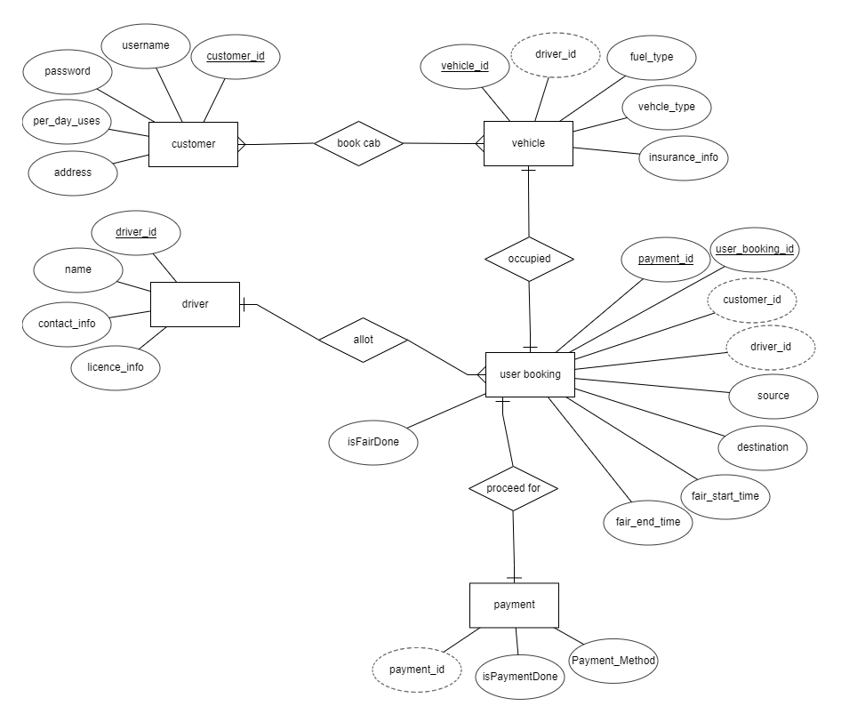

8)Data Dictionary

**1.CUSTOMER**

|  |  |  |  |  |  |
| --- | --- | --- | --- | --- | --- |
| **Attribute name** | **Data Type** | **PK** | **Unique** | **Ref** | **Description** |
| Customer_id | Int | Yes | Yes |  | Unique id of cab Customer |
| Username | Varchar | No | No |  | Username of customer |
| Password | Varchar | No | No |  | Password |
| Contact_no | Number | No | Yes |  | Contact info of customer |
| Per_day_uses | Number | No | No |  | Per day use of cab of customer |
| Address | Varchar | No | No |  | Address of customer |

**2.VEHICLE**

|  |  |  |  |  |  |
| --- | --- | --- | --- | --- | --- |
| **Attribute name** | **Data Type** | **PK** | **Unique** | **Ref** | **Description** |
| Vehicle_id | Int | Yes | Yes |  | Vehicle id of vehicle |
| Driver_id | Int | No | No |  | Driver id of vehicle |
| Fuel_type | Varchar | No | No |  | Petrol, diesel, etc. |
| Vehicle_type | Varchar | No | No |  | Audi, Mercedes, etc. |
| Insurance_info | Varchar | No | No |  | Insurance information of vehicle. |

**3.DRIVER**

|  |  |  |  |  |  |
| --- | --- | --- | --- | --- | --- |
| **Attribute name** | **Data Type** | **PK** | **Unique** | **Ref** | **Description** |
| Driver_id | Int | Yes | Yes | VEHICLE | Unique id of cab driver |
| Name | Varchar | No | No |  | Driver name |
| Contact_no | Number | No | Yes |  | Contact info of driver |
| Licence_no | Varchar | No | Yes |  | Licence info of driver |

**4.USER_BOOKING**

|  |  |  |  |  |  |
| --- | --- | --- | --- | --- | --- |
| **Attribute name** | **Data Type** | **PK** | **Unique** | **Ref** | **Description** |
| User_booking_id | Int | Yes | Yes |  | Booking id |
| Customer_id | Int | No | No | CUSTOMER | Customer id |
| Driver_id | Int | No | No | DRIVER | Driver id |
| Source | Varchar | No | No |  | Source Address |
| Destination | Varchar | No | No |  | Destination address |
| Fair_start_time | Datetime | No | No |  | Fair start time |
| Fair_end_time | Datetime | No | No |  | Fair end time |
| isFairDone | Boolean | No | No |  | Boolean value which indicates that fair is done or not |
| Payment_id | Int | No | No | Payment | Payment id |

**5.PAYMENT**

|  |  |  |  |  |  |
| --- | --- | --- | --- | --- | --- |
| **Attribute name** | **Data Type** | **PK** | **Unique** | **Ref** | **Description** |
| Driver_id | Int | Yes | Yes | Vehicle | Unique id of cab driver |
| Name | Varchar | No | No |  | Name of cab driver |
| Contact_No | Number | No | Yes |  | Contact Info |
| Licence_No | Varchar | No | Yes |  | Licence info of driver |

**Implementation Detail**

1. **Driver side**

* Set the current location – Driver can add its current location
* Show accepted cab request – Driver can accept the cab request and can see the all accepted cab requests.
* Show all cab requests – Driver can see all request which are generated by the customer either is accepted or not.
* View daily earnings – Driver can see his daily earnings
* Set the fair as completed – Driver can set the fair as completed for accepted cab requests.
* Rejecting cab request – Driver can reject the cab

Requests

1. **Customer side**

* Search cabs – customer can search different cabs for his trip by providing the information like source and destination.
* Book cabs – customer can book cab by providing general information like driver ID, name and the distance between two cities.
* Show all pending requests – customer can see his/her all requests which are not accepted or rejected yet.
* Show all accepted requests – customer can see his/her all requests which are accepted by the driver.
* Show all rejected requests – customer can see his/her all requests which are rejected by the driver.

**Screen-shots**

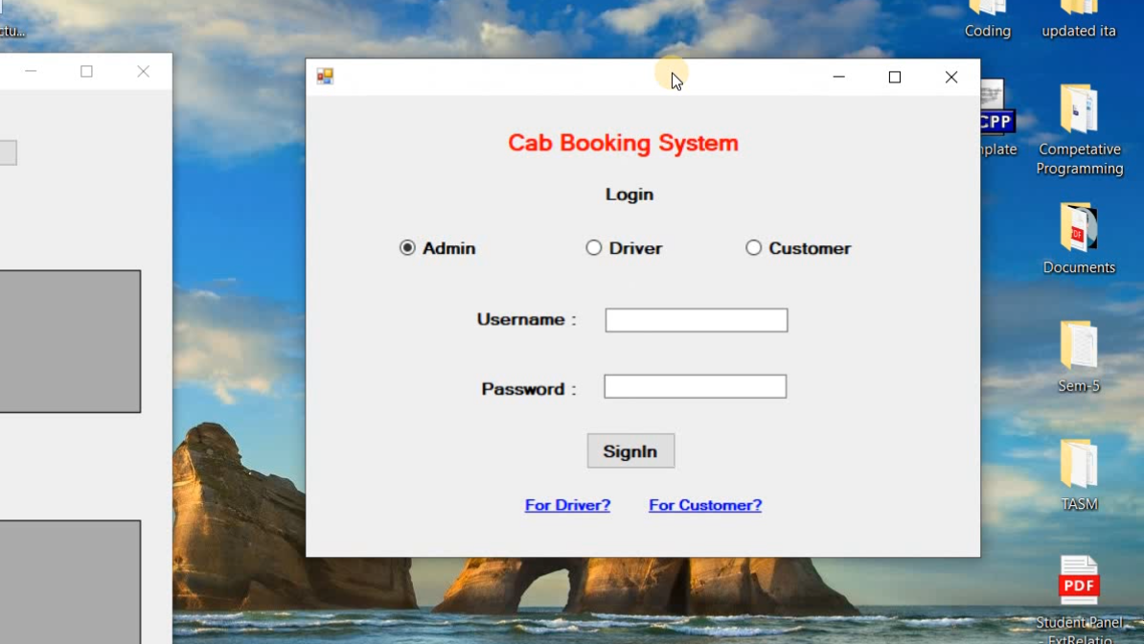

1. Login page of the system

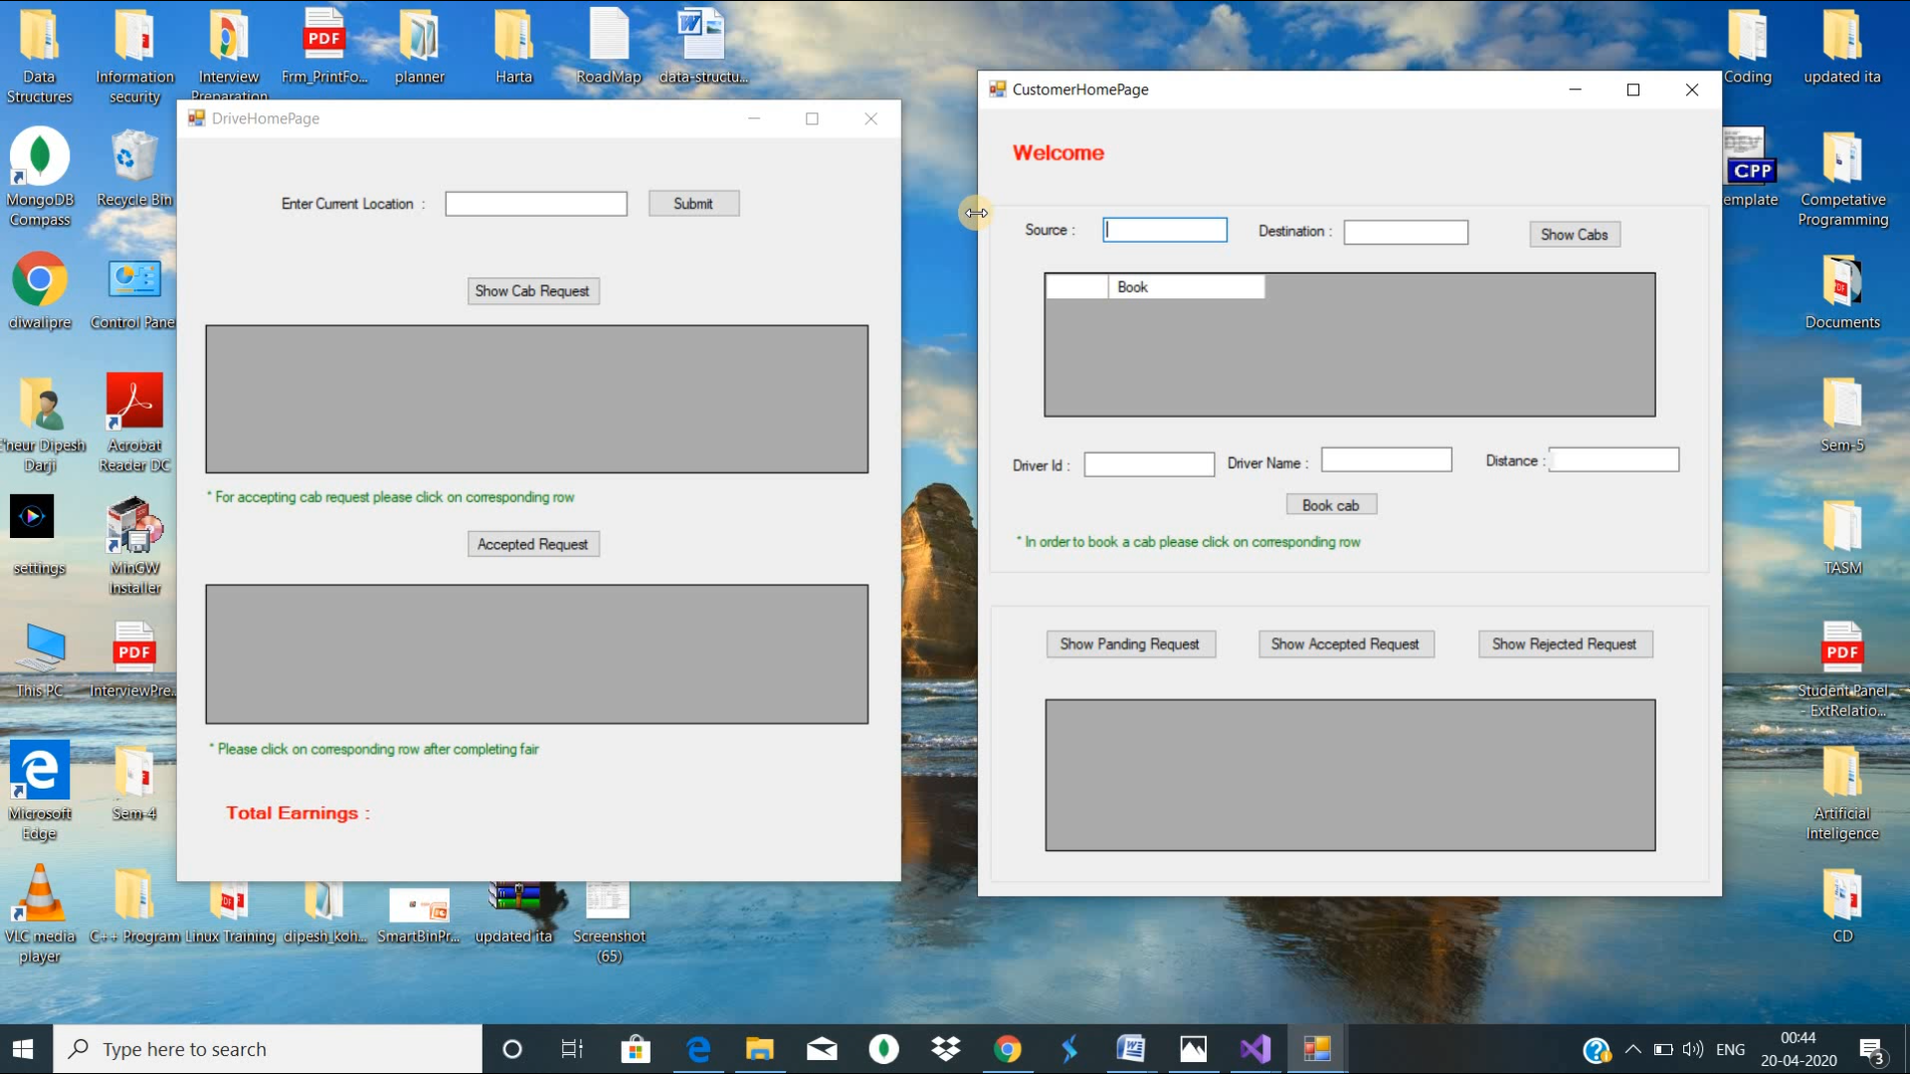

1. Home page for Driver and customer respectively.

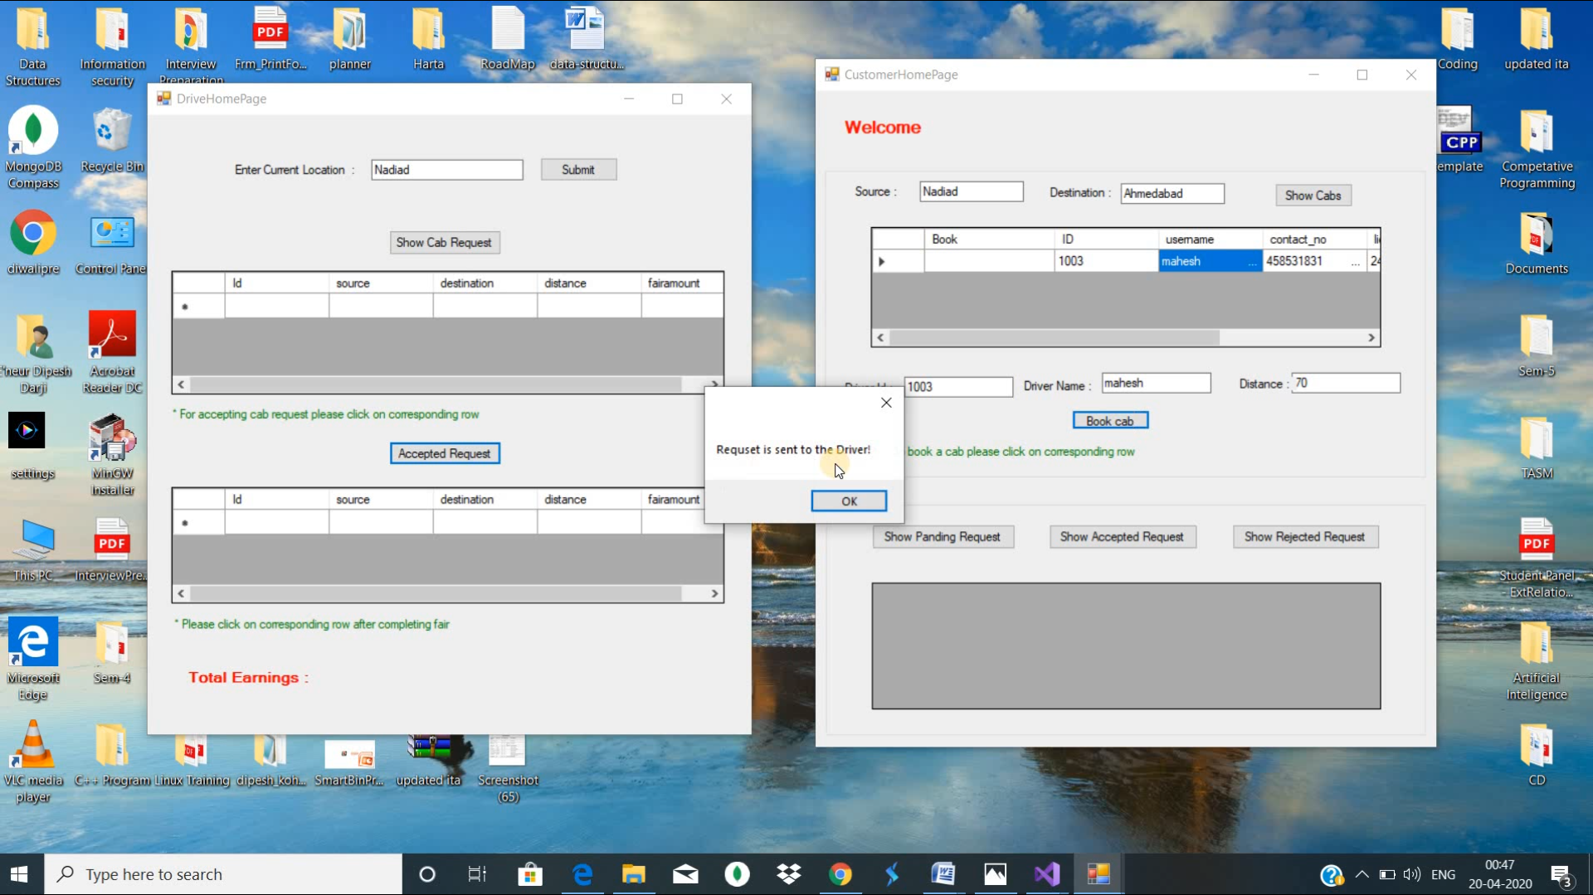

1. View when request is sent to the driver

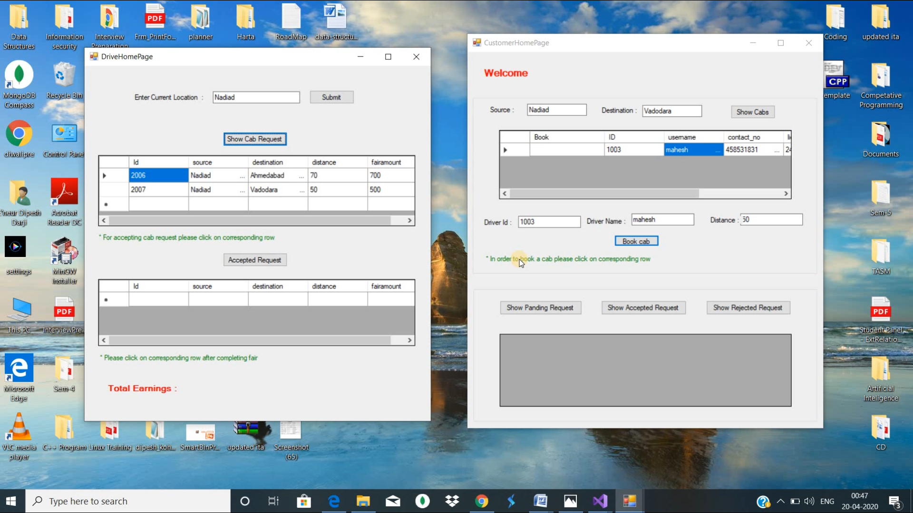

1. View of Show cabs for Driver

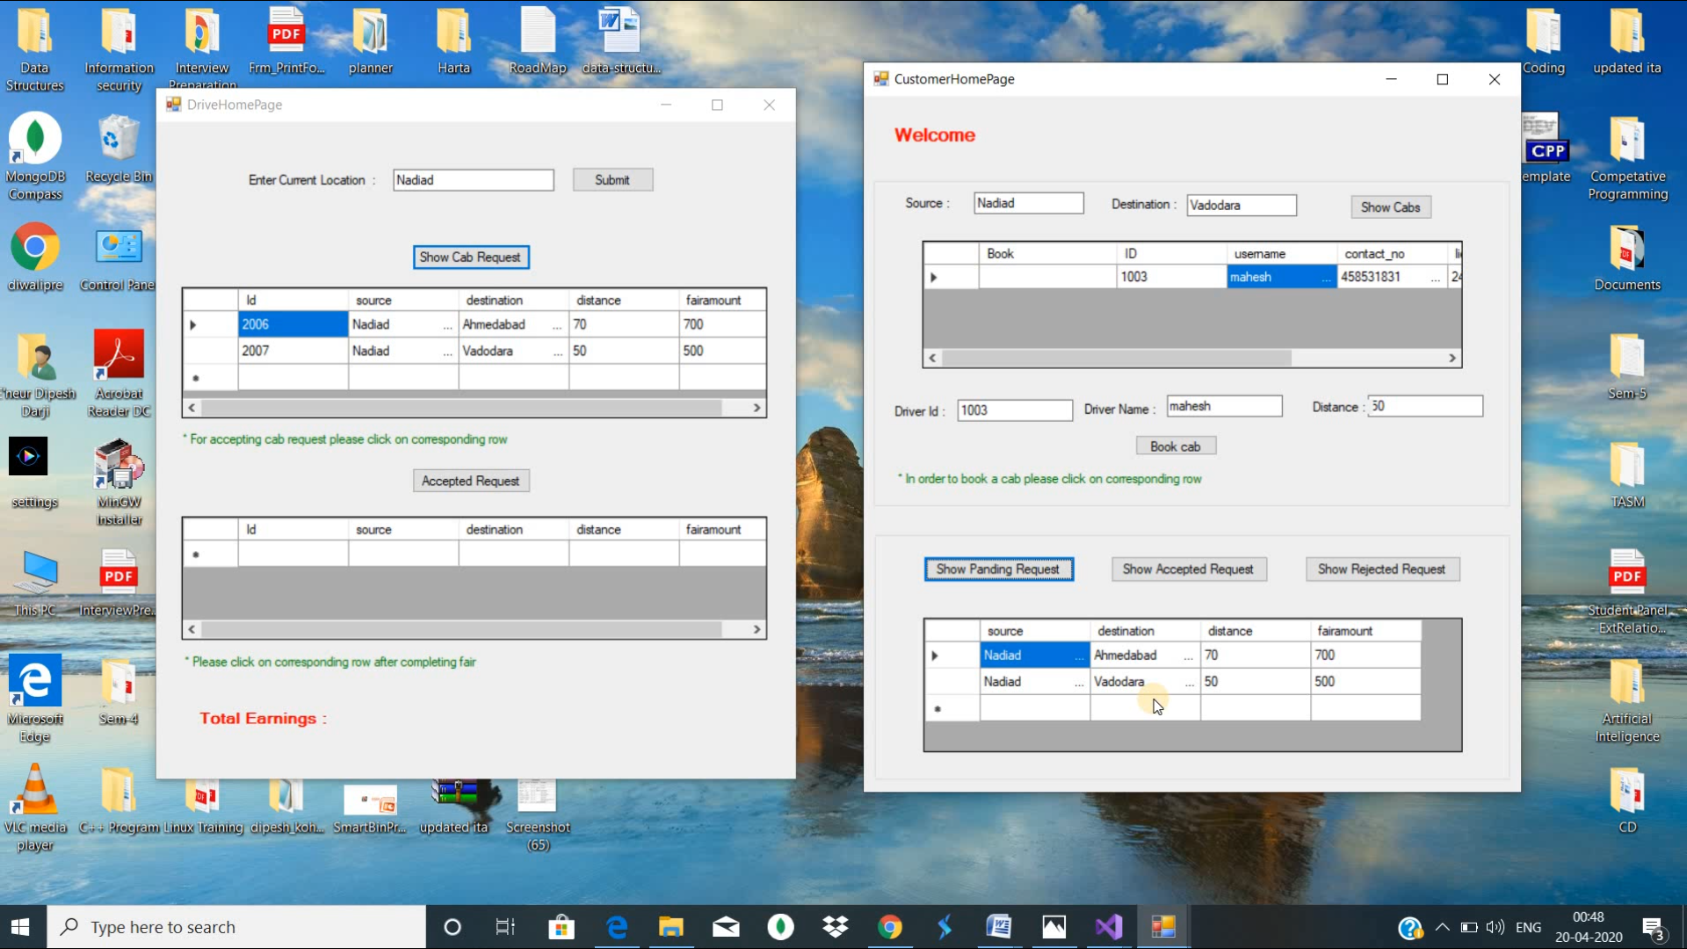

1. View of show pending requests

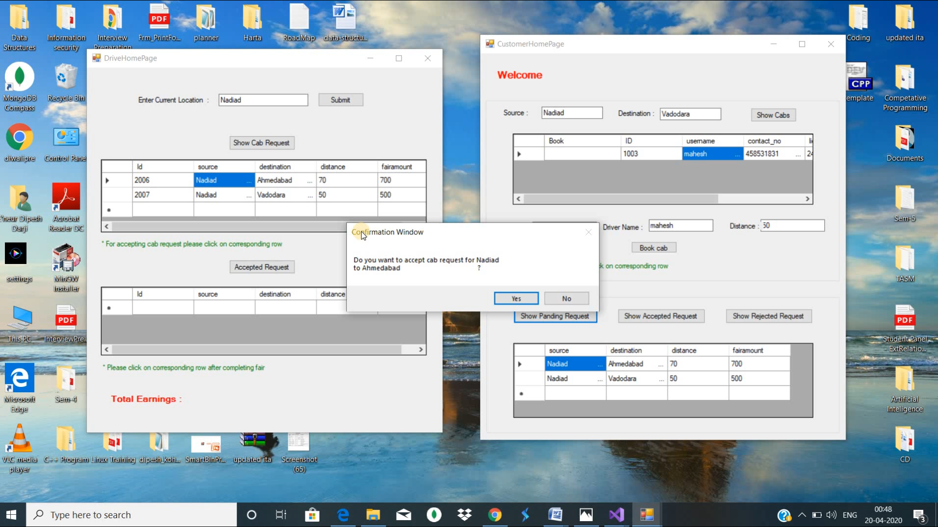

1. View of when driver accept or reject the cab requests

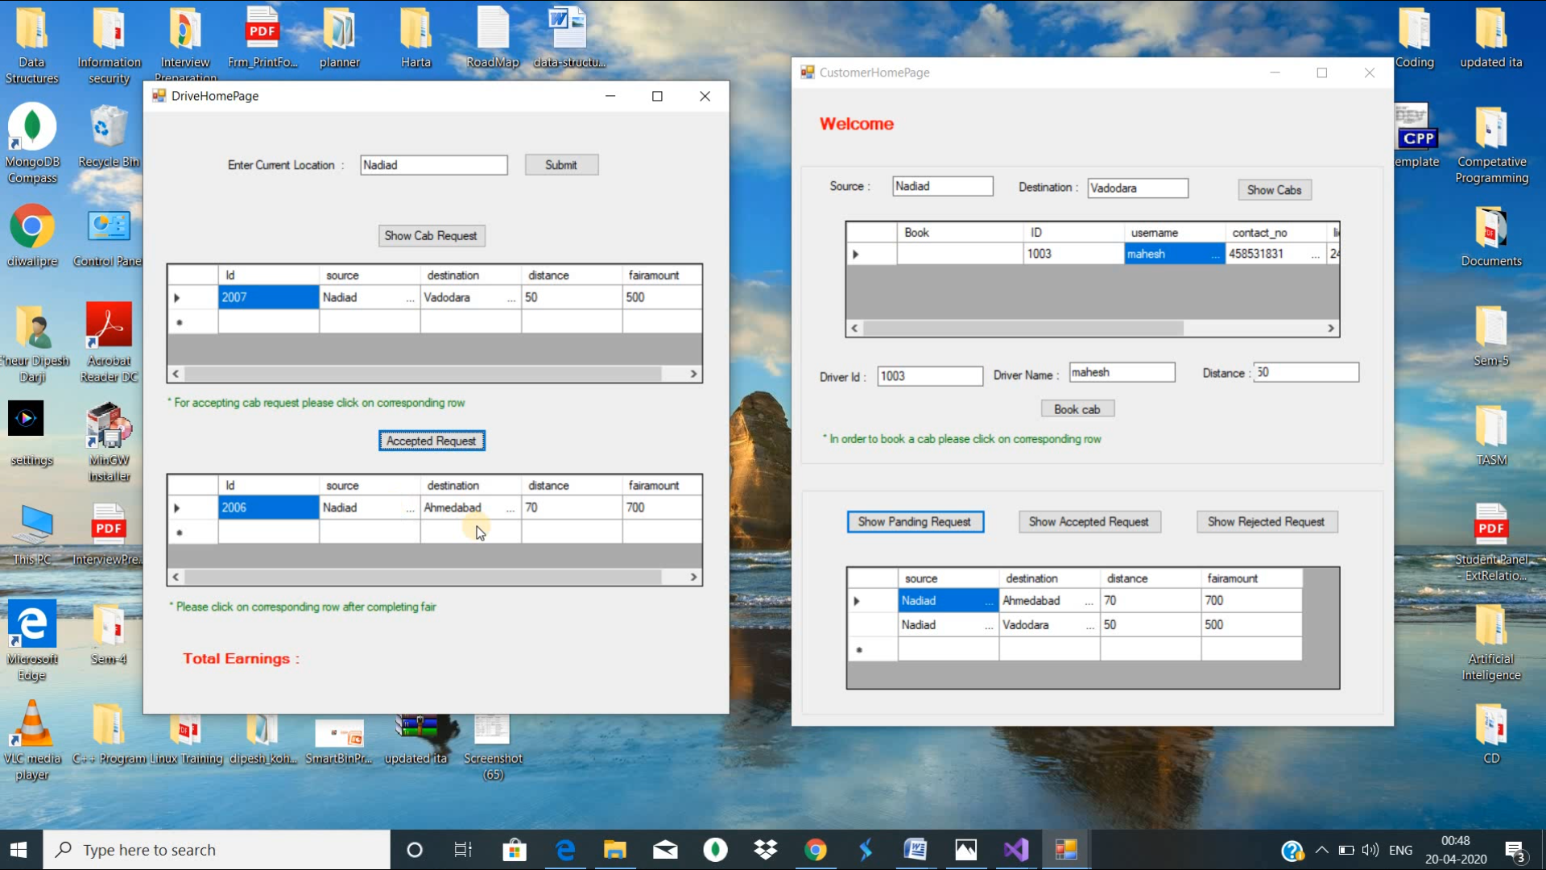

1. View of accepted all cab request for the driver.

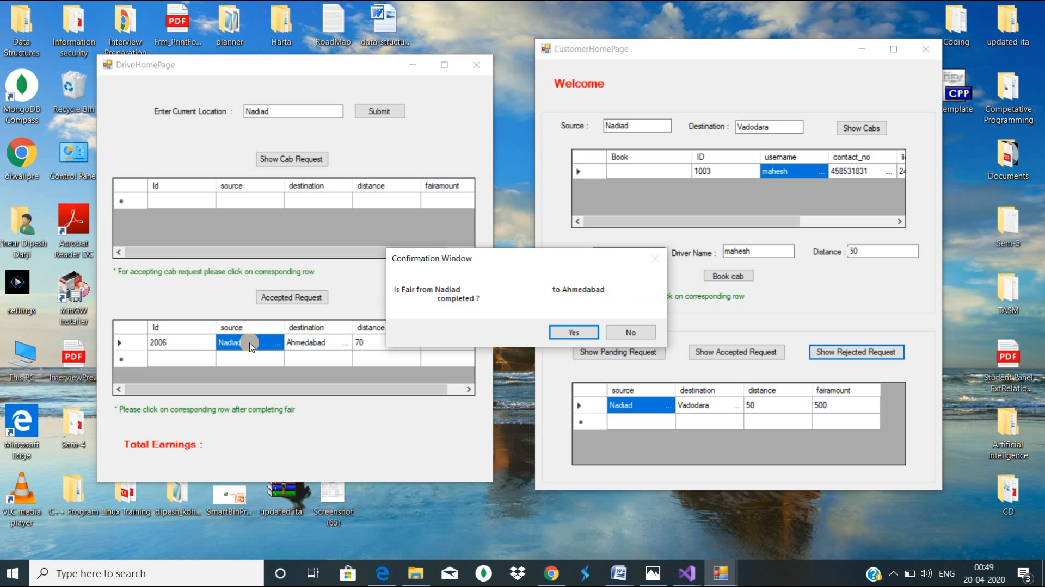

8.View when driver completes his fair.

**Conclusion**

Cab booking System is very effective, efficient, reliable and economic from all aspects. It provides all the current needs of a client when it comes to cab booking services. The proposed project is very flexible, so new features and modules can be added in future as per user requirements. We have implemented all the functionalities in driver side. Driver can accept, rejects the cab requests, setting the current locations, completing the fair, etc. Customer has all rights to book any cab/driver which is added by driver.

**Limitation and Future Extension**

* Application has lacks in terms of security aspects.
* **Future Enhancements**
  + If an appropriate module for secure payment identified or externally developed, then it shall be incorporated in the next version.
  + Customers live location shall be added.
  + Customer can track the current location of cab/driver which has been booked by customer.
  + Admin can provides the offers.

**BIBLIOGRAPHY**

For the successful implementation of this project we referred to many websites and books. The schema was designed by taking ideas from website like <https://www.creately.com>. We created ER Diagram on ERDplus website and developed Desktop application on visual studio 2015.

**Reference Websites:**

* [**http://vbtutor.net**](http://vbtutor.net)
* [**https://docs.microsoft.com/**](https://docs.microsoft.com/)
* [**https://www.tutorialspoint.com/**](https://www.tutorialspoint.com/)